**Assignment – 2**

• Connecting to the Store Sales Data

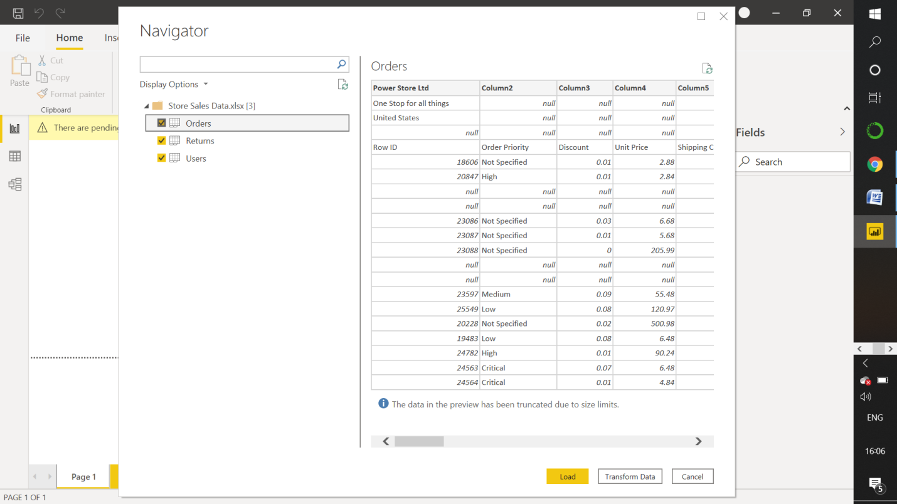

**− Remove all the blank rows.**

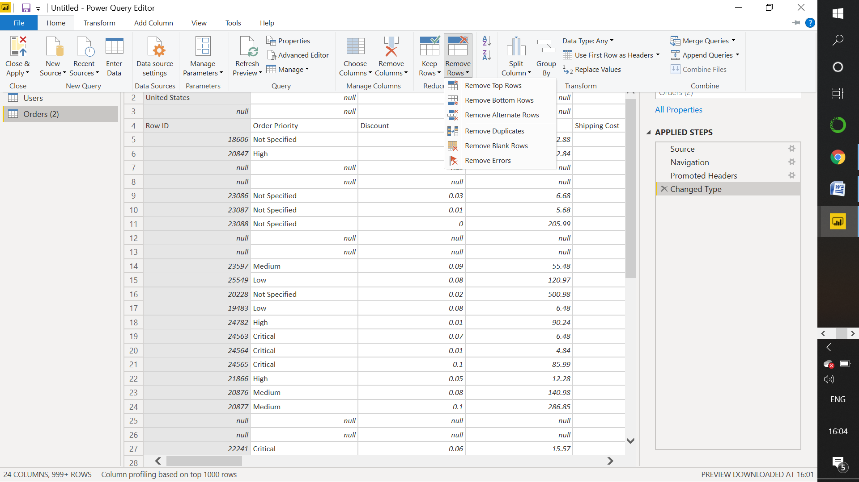

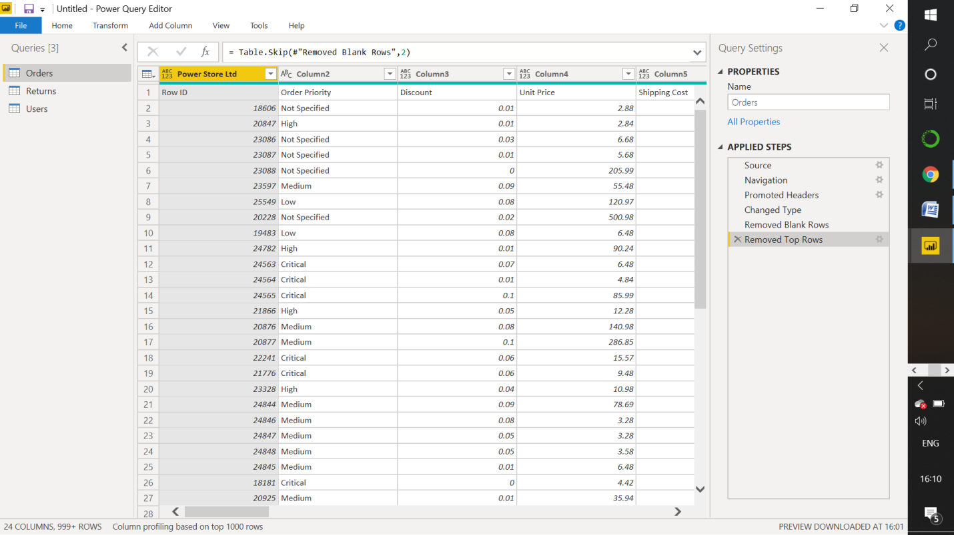

**− Update the column header if they are not updated**

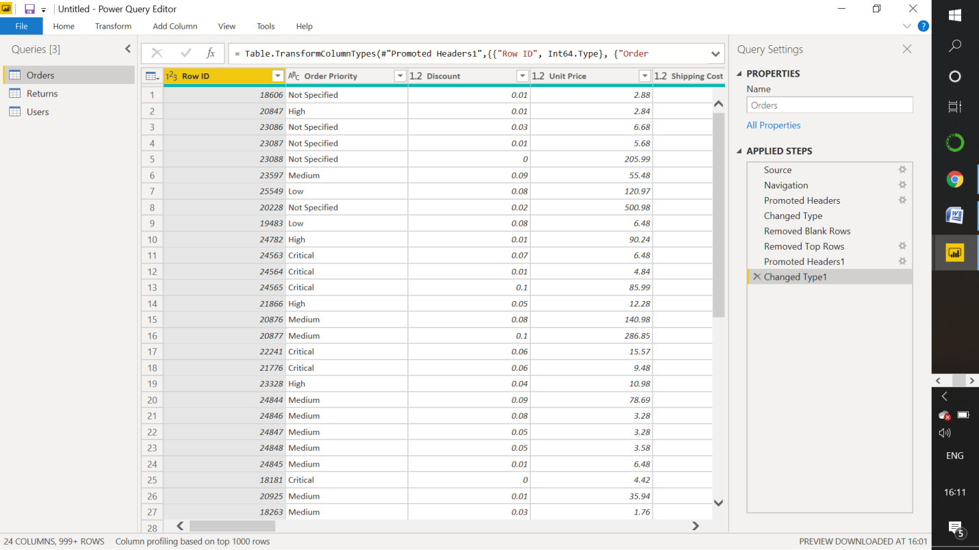

− **Create a text table and show the sales in terms of**

o **Customers**

**o Product Category**

**o Regions**

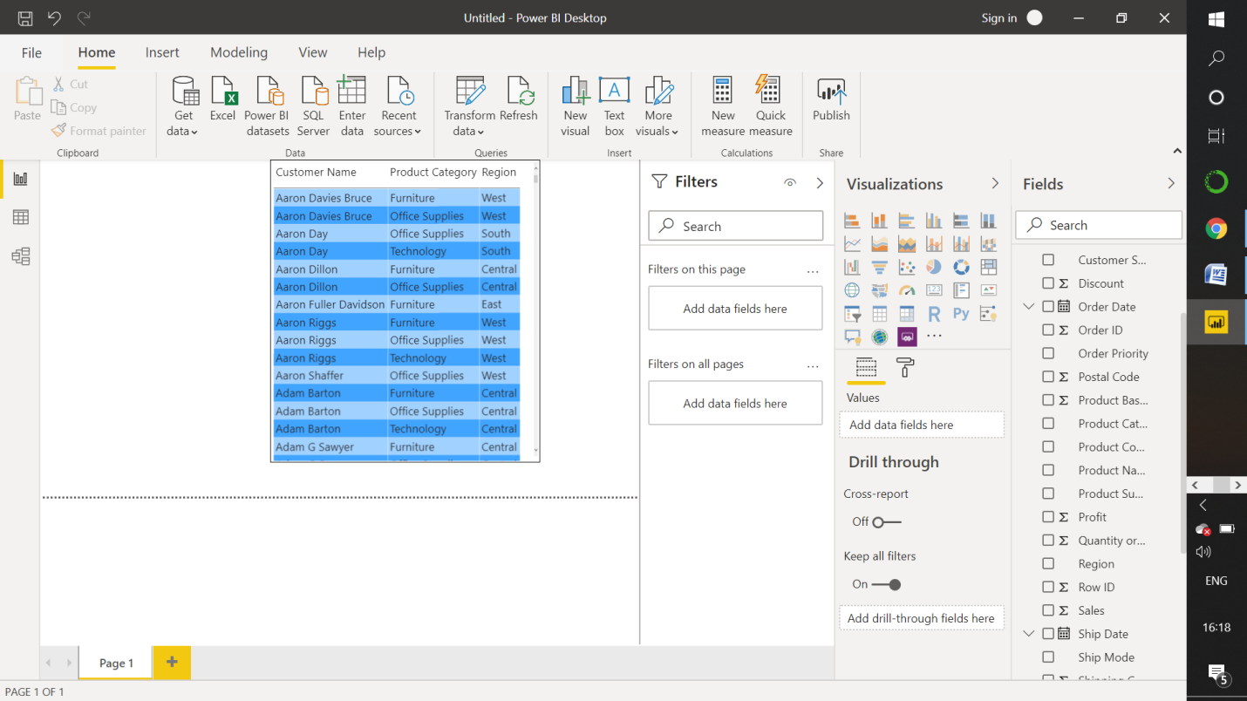

**• Create a line and Clustered Column Chart showing the Sales and Discount as per the State or Province**

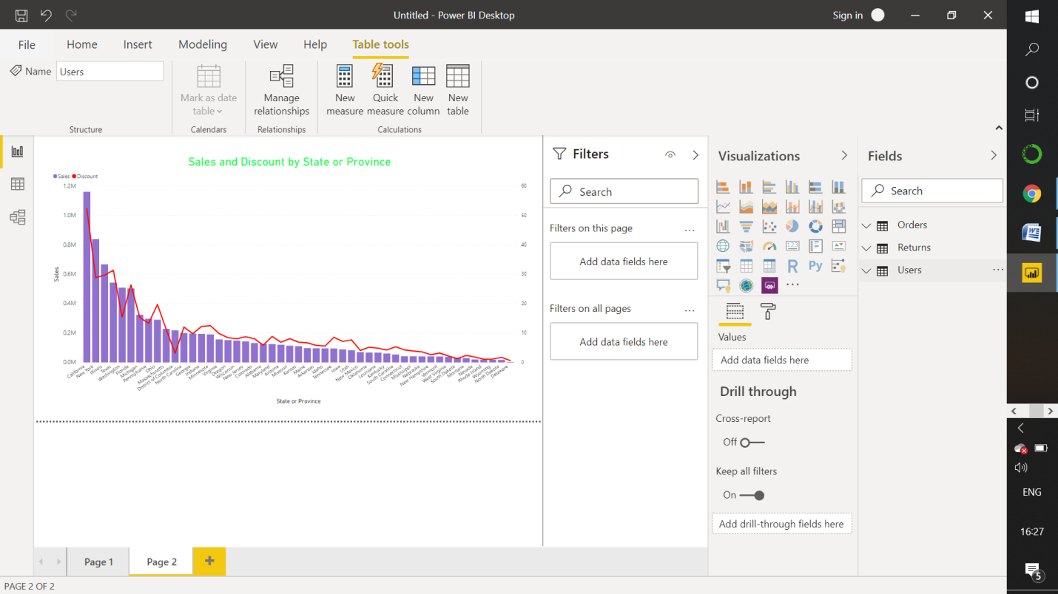

**− Format the bars and line with different colors − Which state has the highest sales in terms Technology**

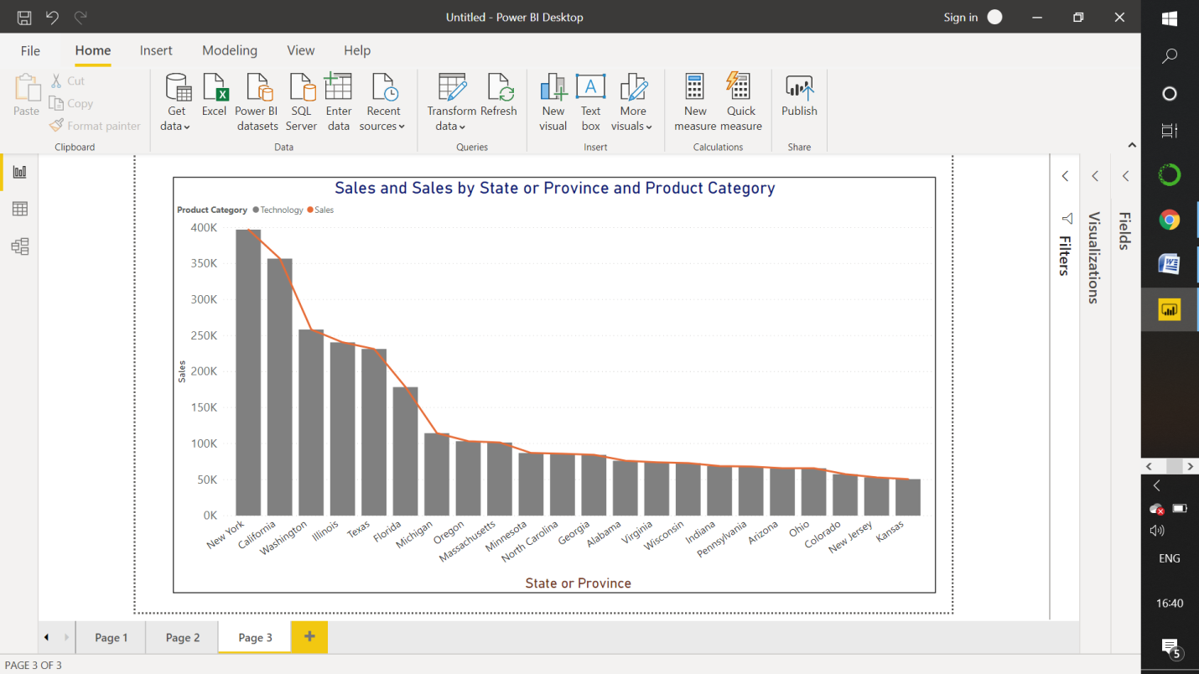

**• Create a Donut Chart showing sales in terms of Product category**

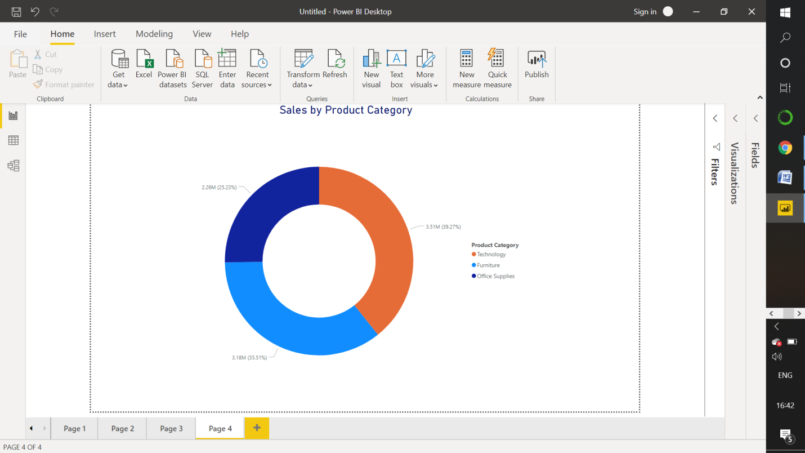

**• Create a Slicer and show the regions in dropdown. See how all the visuals mentioned above behaving when a particular region is selected.**

